FOREST FIRE REAL TIME
MONITORING SYSTEM

GROUP 09
2022E002
2022E006
2022E062
2022E070
2020E102

INTRODUCTION
Forest fires can cause devastating damage to ecosystems, wildlife, and human settlements. Early detection is critical to prevent large-scale loss. This project proposes an automated forest fire monitoring system using an ATmega328 microcontroller equipped with temperature, humidity, and smoke sensors, and a LoRa module for wireless communication. The system periodically monitors environmental conditions and sends data to a central LoRa gateway, which can then forward alerts to a cloud server or monitoring dashboard. By using LoRa technology, the system achieves long-range, low-power wireless communication, making it suitable for remote forest areas where traditional networks are unavailable.
DESIGN OVERVIEW
Sensor Node:
- ATmega328 MCU
- Sensors: DHT22 (temperature & humidity), MQ-2 (smoke)
- LoRa Module (SX1278 / RFM95)
Central Gateway:
- LoRa Gateway (receives data from multiple nodes)
- Forwards data to cloud server / dashboard via Ethernet/Wi-Fi
Monitoring Dashboard / Mobile App:
- Displays real-time sensor readings and alerts
- Visualizes fire location on map

Communication Protocols
Component Communication | Protocol | Justification
ATmega328 ↔ DHT22 | Digital Single-Wire | Easy, low number of pins needed
ATmega328 ↔ MQ-2 | Analog input | Easy, Low number of pins needed
ATmega328 ↔ LoRa Module | UART | Fast, reliable, widely supported by SX1278/  RFM95
LoRa Gateway ↔ Cloud | HTTP | Secure, and standard for IOT products
GPS <-> TTmega328P | UART | Secure.Standard

Circuit Design
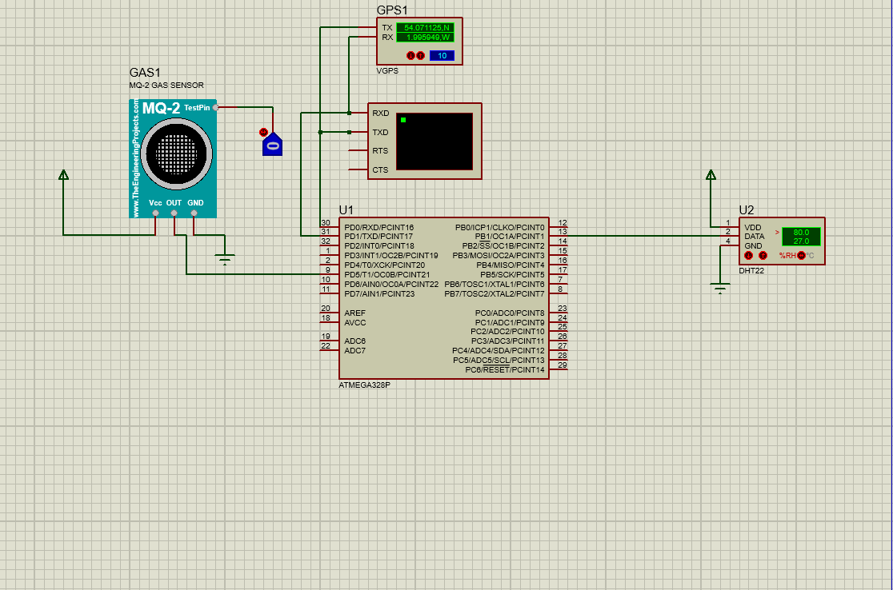

SYSTEM ARCHIRECTURE
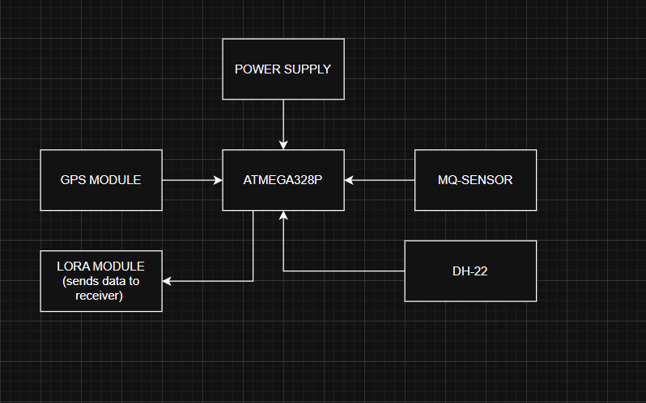
The proposed system architecture uses an ATmega328P microcontroller as the main control unit, integrated with a GPS module and a LoRa transceiver to enable long-range, low-power wireless communication. The GPS module interfaces with the microcontroller through UART and continuously provides real-time location information such as latitude and longitude using NMEA sentences. The ATmega328P processes this GPS data along with inputs from connected sensors via its ADC and digital I/O pins. The system sends the recorded data for every 5 seconds with the GPS coordinates into a compact data packet and transmits it through the LoRa module using SPI communication. The LoRa module sends this packet wirelessly over long distances to a LoRa gateway or receiver node, which forwards the data to a remote server or monitoring station for visualization and alerts. A regulated power supply unit powers all system components, enabling reliable and energy-efficient operation suitable for remote and wide-area monitoring applications.
TECNOLOGIES TO BE USED
Hardware Components
1.ATmega328
2.DH22
3.MQ-2
4.Lora Modules
5.Resistors
6.Breadboard
7.Jumper wires
8.Crystal Oscillator
Software Technologies
Embedded C: Firmware development
HTML & CSS: Structure and styling of the web interface
JavaScript: Client-side interactivity and dynamic updates
Node.js: Backend server and API handling
RESTful APIs: Communication between hardware system and web application
GitHub: Version control and project documentation

UNIQUENESS
Using of LoRa technology which works independent of the GSM or Wi-Fi.
Uses low power for signal transmission which makes it long lasting.
Sending data periodically which helps to create real time monitoring system.

BUDGET
No. | Component | Quantity | Unit Price (LKR) | Total (LKR)
1 | LoRa Module | 2 | 1500 | 3000
2 | ATmega328 & Arduino Board | 1 | 2500 | 2500
3 | MQ-2 Gas Sensor | 1 | 350 | 350
4 | DHT22 Sensor | 1 | 340 | 340
5 | Resistors (1kΩ, 220Ω) | — | 50 | 50
6 | GPS Module | 1 | 1650 | 1650
 | Total Cost |  |  | 7890 LKR

TIMELINE
Week 01 -Week 03 | Project Planning, Creating Project proposal
Week 04 | Components Purchasing, Testing the components
Week 05 | Project Simulation
Week 06 -Week 07 | Creating Prototype of the Project
Week 08 -Week 09 | Creating the software needed to visualize the output
Week 10 -Week 11 | Designing the PCB Layout
Week 12 -Week 14 | Implementing the complete Design to custom designed PCB
Week 15 | Presentation

